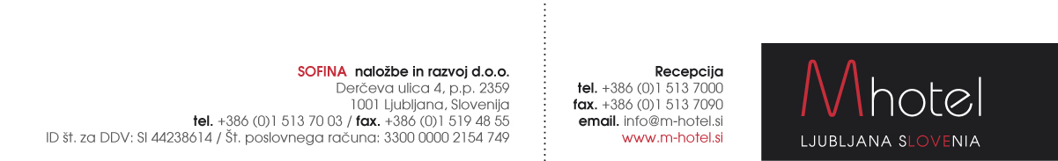

**IFHOH CONFERENCE RESERVATION FORM**

**M HOTEL IS THE OFFICIAL HOTEL OF THE IFHOH CONFERENCE**

**(10.5. – 12.5.2018)**

Reservations to be sent to the following e-mail address: [**anja.novak@m-hotel.si**](mailto:anja.novak@m-hotel.si)

|  |  |
| --- | --- |
| First and last name: |  |
| Room type and number of persons: |  |
| Arrival date: |  |
| Departure date: |  |

**Special rates:**

|  |  |
| --- | --- |
| Single Comfort room:  Double / twin room:  Tourist tax: | 110 EUR / night.  130 EUR / night  1,27 EUR / person / night. Will be subject to change. |

Payments: Payments to be made directly at the hotel.

Limited no. of the rooms are reserved. Dead-line for reservations 10.3.2018

**M hotel offers you a transfer service from/to the following airport:**

|  |  |  |  |  |  |  |
| --- | --- | --- | --- | --- | --- | --- |
| |  |  | | --- | --- | |  | NUMBER OF PERSONS | |  | Up to 4 | | JOŽE PUČNIK LJUBLJANA AIRPORT – M HOTEL | 30,00 EUR | |

Our taxi driver will be waiting for you at the arrival gate with an M hotel sign and your name on it. Payment: directly to taxi driver.

**IN CASE YOU NEED OUR TRANSFER SERVICE PLEASE FILL IN YOUR FLIGHT DETAILS:**

ARRIVAL DATE:

ARRIVAL TIME:

FLIGHT NUMBER:

NUMBER OF PERSONS:

